i ii
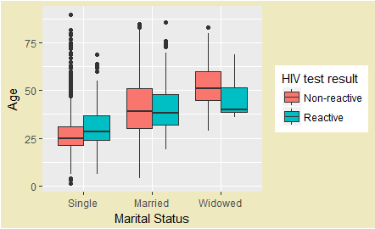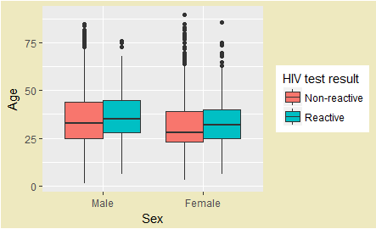
Figure S1. Median age at HIV diagnosis by i. Marital status, and ii. Sex.

